BOARD CHARTER
AFRICAN SOLIDARITY CIVIC ORGANISATION (ASCO)
Version: 1.0
Effective Date: 8 September 2026
Approved by the Board on: 6 September 2026
1. PURPOSE
The purpose of this Charter is to define the role, authority, responsibilities and governance framework of the Board of Directors of African Solidarity Civic Organisation (ASCO). The Board exists to provide strategic leadership, ensure accountability, promote ethical governance, safeguard organisational assets and advance ASCO’s mission of promoting African solidarity, human dignity, peace, social justice, sustainable development and community empowerment.
2. GOVERNING PRINCIPLES
The Board shall conduct its affairs in accordance with:
• Companies Act 71 of 2008.
ASCO’s Memorandum of Incorporation (MOI).
•ASCO’s Constitution.
•Applicable South African legislation.
•The principles of good governance, transparency and accountability.
3. ROLE OF THE BOARD
The Board shall:
•Determine ASCO’s strategic direction.
•Approve organisational policies.
•Protect the mission and values of ASCO.
•Ensure financial sustainability.
•Monitor organisational performance.
•Ensure legal and regulatory compliance.
•Exercise oversight over Executive Management.
•Promote ethical leadership and integrity. The Board shall not interfere with routine operational management except where necessary to fulfil its governance responsibilities.
4. SEPARATION OF GOVERNANCE AND MANAGEMENT
ASCO recognises a clear distinction between governance and management. The Board governs. Executive Management manages. Directors serving in executive capacities shall distinguish between decisions made as Board members and decisions made in their executive management roles. The Board shall not interfere in routine operational management except where necessary to fulfil its governance responsibilities.
5. BOARD COMPOSITION
The Board shall consist of not fewer than three Directors, unless the MOI lawfully specifies a higher number, and may comprise additional Directors in accordance with the MOI, ASCO’s Constitution and applicable law. The current Board structure comprises four Directors, subject to the MOI and applicable law. The Board should collectively possess expertise in:
•Governance
•Finance
•Community Development
•Human Rights
•Law
•Public Policy
•Strategic Planning
•Fundraising
•Risk Management Diversity in gender, age, nationality and professional background shall be encouraged.
6. BOARD RESPONSIBILITIES
The Board shall: Strategy
•Approve strategic plans.
•Review progress annually. Finance
•Approve annual budgets.
•Review financial reports.
•Safeguard organisational assets.
•Approve audited financial statements. Governance
•Approve governance policies.
•Monitor Board effectiveness.
•Ensure compliance. Risk
•Identify strategic risks.
•Monitor mitigation measures. Resource Mobilisation Support fundraising initiatives while ensuring independence and accountability. Executive Oversight
•Appoint the Executive Director.
•Evaluate the Executive Director’s performance.
•Approve organisational structure.
7. EXECUTIVE MANAGEMENT
Executive Management is responsible for:
•Implementing Board decisions.
•Managing programmes.
•Managing employees and volunteers.
•Financial administration.
•Stakeholder engagement.
•Operational planning.
•Reporting to the Board. The Executive Director shall be accountable to the Board.
8. OFFICE BEARERS
Chairperson The Chairperson shall:
•Lead the Board.
•Preside over Board meetings.
•Ensure effective governance.
•Facilitate strategic discussions.
•Evaluate Board performance. The Chairperson shall not interfere in day-to-day operations unless authorised by the Board. Deputy Chairperson The Deputy Chairperson shall:
•Support the Chairperson.
•Act in the Chairperson’s absence.
•Undertake delegated governance responsibilities. Executive Director The Executive Director shall:
•Serve as Chief Executive Officer of ASCO.
•Implement Board decisions.
•Lead organisational operations.
•Represent ASCO externally.
•Report to the Board.
•Recommend strategic initiatives. Treasurer / Director of Finance Responsible for:
•Financial oversight.
•Budget preparation.
•Financial reporting.
•Internal controls.
•Compliance with financial legislation. Company Secretary / Board Secretary Responsible for:
•Board administration.
•Minutes.
•Compliance records.
•Board documentation.
•Maintaining statutory registers.
9. BOARD MEETINGS
The Board shall meet:
• At least four (4) times per year.
• Additional meetings may be convened when necessary.
10. CONFLICT OF INTEREST
Every Director shall:
•Declare conflicts of interest.
•Refrain from voting where conflicted.
•Act in the best interests of ASCO. A Register of Interests shall be maintained.
11. CODE OF CONDUCT
Directors shall:
•Act honestly.
•Maintain confidentiality.
•Respect collective decisions.
•Avoid abuse of office.
•Promote unity within ASCO.
•Protect ASCO’s reputation.
12. DELEGATION OF AUTHORITY
The Board may delegate authority to:
•Executive Director
•Board Committees
•Executive Management Delegation does not remove Board accountability.
13. BOARD COMMITTEES
The Board may establish committees as required, including a Finance and Procurement Committee and, where appropriate, Finance and Audit, Governance and Ethics, Human Resources, Resource Mobilisation, Programmes and Risk committees. Committees shall operate under Board-approved terms of reference and report to the Board. Delegation to a committee does not remove Board accountability.
14. BOARD PERFORMANCE
The Board shall annually evaluate:
•Its effectiveness.
•Individual director performance.
•Committee effectiveness.
•Governance practices.
15. CONFIDENTIALITY
Directors shall protect confidential information acquired through their office and shall not disclose such information without Board authorisation unless required by law.
16. REVIEW OF THE CHARTER
This Charter shall be reviewed every three (3) years or earlier if legislative or organisational changes require amendment.
17. ADOPTION
This Board Charter was adopted by the Board of Directors of African Solidarity Civic Organisation (ASCO).
SIGNATURES OF THE BOARD OF DIRECTORS
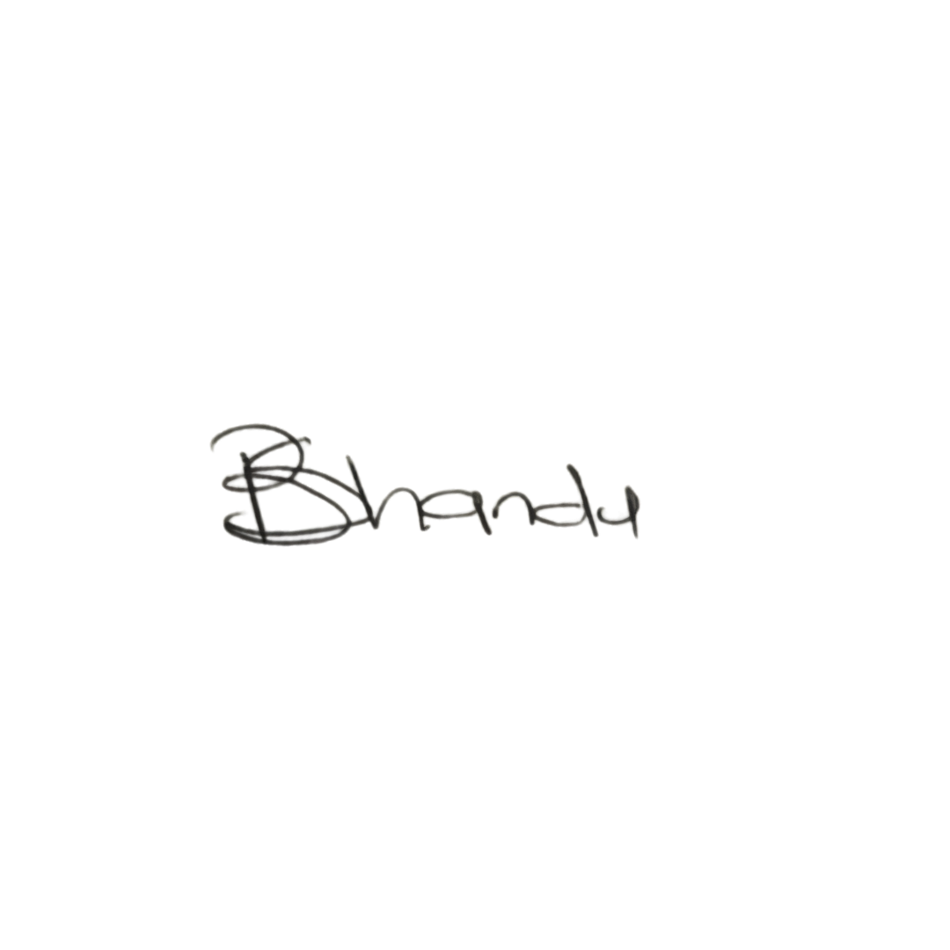  CHAIR LADY  Ms. Busisiwe Makhosi Shandu  Signature:  ____________________________  Date: 6 September 2026  ____________________________ | 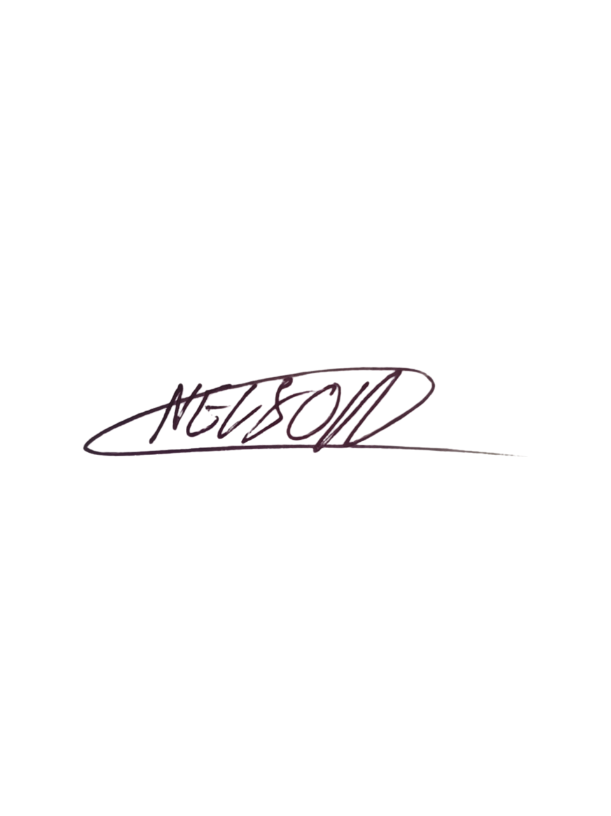  DIRECTOR: HEAD OF ICT AND COMMUNICATIONS  Mr. Thapelo Nelson Maqalika  Signature:  ____________________________  Date: 6 September 2026  ____________________________
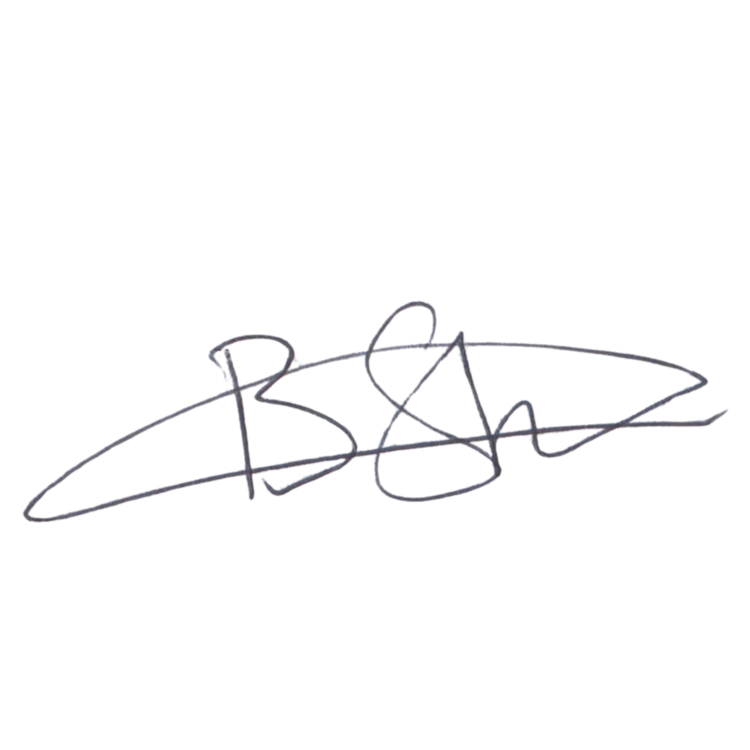  EXECUTIVE DIRECTOR  Mr. Bhekisisa Shandu  Signature:  ____________________________  Date: 6 September 2026  ____________________________ | 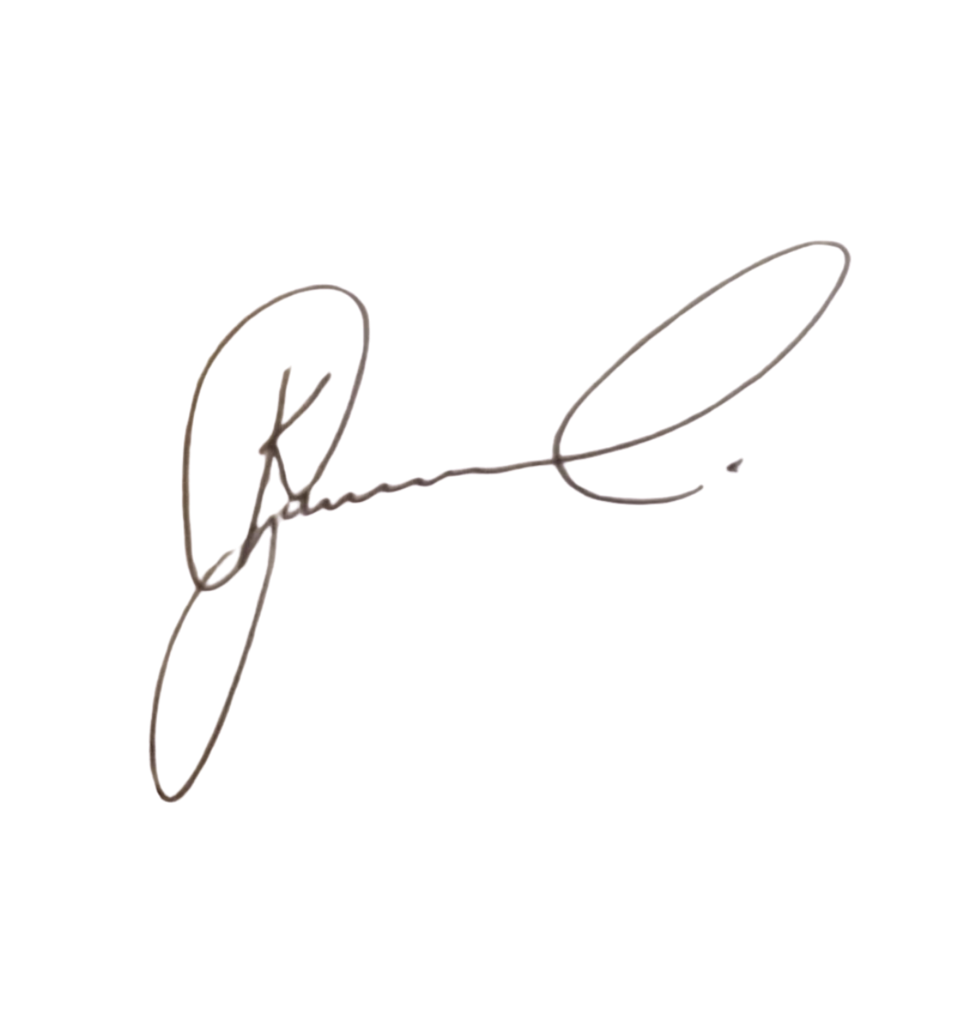  DIRECTOR: PEOPLE AND CULTURE / CHAIRPERSON: FINANCE AND PROCUREMENT COMMITTEE  Mr. Khulekani Gumede  Signature:  ____________________________  Date: 6 September 2026  ____________________________

